**Post Doctoral Fellowship in Neurorehabilitation**

The department of Physical Medicine and Rehabilitation (PMR) has been in existence in CMC Vellore, for more than 50 years and has grown over the years in the number of admissions and in the types of services provided for neurological conditions such as stroke, brain injury, spinal cord injury, peripheral nerve injury and neuromuscular conditions.

The Postdoctoral Fellowship in Neurorehabilitation is a two-year course which is CMC certified. Those who have completed their MD or DNB in PMR are eligible to apply. The objective of this training program is to provide comprehensive and specialized training for Physiatrists in neurorehabilitation, to equip them to become competent, independent and confident in their decision making and management of persons with neurological disorders. This course provides opportunity to learn from interprofessional team meetings, interdisciplinary clinics, follow-up through monthly home visits and annual rehab mela. It also involves developing your research skills and an understanding of advanced rehabilitation made possible through gait analysis, assistive technology, innovations through rehabilitation engineering and robotic services.

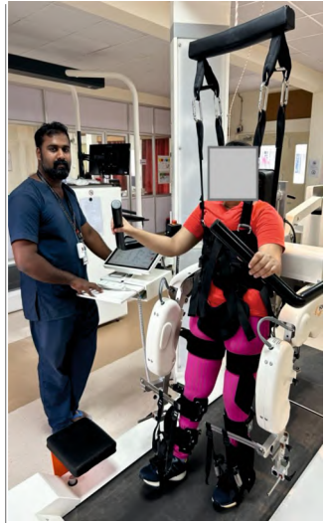

**Eligibility: MD/DNB in PMR**

**Duration: 2 years**

**Knowledge and skills to be acquired on completion of the PDF Course:**

* Knowledge to become proficient at a specialist level, in the comprehensive rehabilitation management of a variety of neurological conditions including acquired brain injury, spinal cord injury, peripheral nerve injury and neuromuscular conditions.
* Developdiagnostic and interventional skills in the management of commonly seen complications, such as:
  + Nutrition and dysphagia
  + Communication disorders
  + Neurogenic bowel and bladder
  + Skin protection
  + Pressure sore management
  + Management of patients with tracheostomies
  + Motor and sensory impairments
  + Cognitive disorders
  + Visual-spatial disorders
  + Sleep hygiene
  + Agitation
  + Neuropsychiatric complications
  + Spasticity/contractures
  + Seizures
  + Pain
  + DVT prophylaxis and management
* Interprofessional skills in leading team discussion and co-coordinating the multidisciplinary care including prescribing of assistive devices and technology such as orthotics, seating systems, adaptive equipment, gait aids, and communication aids in order to improve independent function
* Communication skills for family discussion to explain clinical course of and functional prognosis for the different neurological conditions.
* Research skills and completion of a quality improvement/ academic project/ case series.

**Rotation schedule for candidates in the course:**

| Rotation | Length |
| --- | --- |
| Inpatient rehabilitation  Main Hospital Campus + Procedures  Rehabilitation Campus+ Procedures | 6months  6months |
| Hosp OPD +Clinics+ consults | 2months |
| Ranipet OPD/IPD + Clinics + consults | 6months |
| Chittoor Campus + Procedures | 2months |
| Electives+ Research + Procedures  (Neurology/Neuro-trauma/Spine) | 2months |